

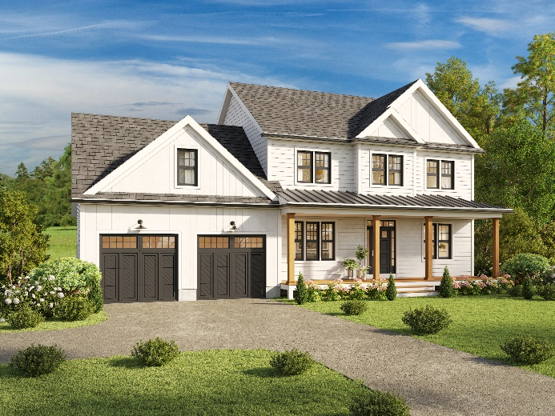

Project Specification Sheet
Project Address: 140 Abbott Valley Run, Cumberland, RI
Designer: Ian E. Souza, I.E. Designs
Contact: Pat@Millerpropertiesri.com (401) 793-1519

General Building Details
- Style: Two-story single-family home
- Total Floors: Basement + 1st Floor + 2nd Floor
- Garage: Attached 2-car garage
- Exterior Siding:
  - Vinyl Clapboard
  - Vinyl Board & Batten Siding
- Roof Type: Gable & Hip roof design
- Roofing Material: Architectural Asphalt Shingles (30-year rated)
- Trim: 5½" Vinyl Corner Trim, Aluminum Coil Rake Trim (White)
- Soffit: Vented Vinyl Soffit
- Fascia: 1x8 Board

Dimensions (Approximated from plans)
- Ceiling Heights:
  - First Floor: 9 ft
  - Second Floor: 8 ft except for 9ft Trey Ceiling in master bedroom
  - Garage Slab to Ceiling: ~8 ft
- Roof Pitch (varies):
  - Front and main roof: 9:12
  - Garage and dormer: 4:12, 8:12, 10:12, 12:12 depending on location

Framing & Structural Components
- Wall Framing:
  - 2x6 Stud Walls @ 16" O.C. (Garage + Exterior)
  - 2x4 Stud Walls @ 16" O.C. (Interior)
- Joists & Rafters:
  - Floor: 2x12 Joists @ 16" O.C.
  - Ceiling: 2x10 Joists @ 16" O.C.
  - Roof: 2x12 Rafters @ 16" O.C. with Collar Ties
- Beams:
  - Multiple LVL (Laminated Veneer Lumber) Beams, including (4)-1¾"x18" and (3)-1¾"x11¼" in key areas
- Subfloor: ¾" T&G Plywood, glued and ring nailed

Foundation & Basement
- Foundation Wall: 10" Thick Concrete w/ (2)-#4 Rebar Top & Bottom
- Footings: 12"x20" Continuous Poured Concrete (2500 PSI), 48" Below Grade
- Basement Floor Slab: 4" Thick Concrete
- Foundation Damp-proofing: Applied to grade level

Insulation & Energy Efficiency
- Exterior Walls (conditioned): R-21 Batt with Vapor Barrier
- Basement Ceiling: R-30 Batt with Vapor Barrier
- Garage Walls: R-21 Insulation with Vapor Barrier
- Attic/Ceiling: R-38 Insulation
- Rim/Band Joists: Closed-cell Spray Foam
- Compliance: Must meet 2024 IECC and Rhode Island Energy Code

Construction Compliance & Notes
- All construction to conform to Massachusetts 110 MPH Exposure B wind code
- Compliance with the 2015 IRC (International Residential Code)
- Decks to be built per AWC Prescriptive Residential Deck Construction Guide
- Railings required for decks over 30" from grade

Additional Notes

- Electrical: All decks, balconies, and porches require at least one receptacle
- Finishes and Materials: To be coordinated and finalized between Owner and Contractor
- Kitchen Cabinets: Default is White Deluxe shaker style, Modifications to door style or color will incur an additional charge.
- Countertops: Quartz, Modifications to Material type will incur an additional charge.
- Light Fixtures: Recessed lighting, Fans, Exterior lighting, Landscaping lighting?
- Paint: 3 Sherwin Williams colors allowance, more than 3 will incur an additional charge.
- Hardware: Black hardware throughout (Doorknobs, Cabinet pulls)
- Flooring: 4” White oak in natural finish throughout, Tile in all bathrooms.
- Doors: Solid core 2 panel shaker
- Kitchen Appliances: High end Black stainless steel
- Patio: 12’x20’ Paver patio in Keystone Panorama Supra Paver 3 pc. Granite Blend, Modifications to Style & Color will incur an additional charge.
WWW.MillerPropertiesRI.COM

